**Additional Resources on Post Trade: Prime Finance and Global Clearing Overview**

Prime Finance: Prime Finance is a product offering for the post-trade stage of a trade cycle. A typical transaction flow in Prime Finance is illustrated below, which involves three stages: execution🡪trade reporting🡪trade settlement.

Revenue is driven by trading activities primarily in the equities and derivatives market. Prime Finance generally earns income through client’s debit interest from financing long positions and short fee from securities lending. The client base of Prime Finance consists of hedge funds that run a variety of strategies such as equity long/short, quantitative, credit, and event-driven.

Clearing: Post the Dodd Frank Act in 2012, certain derivative products are required to be centrally cleared at clearing houses, and through a “clearing member” or FCM, such as J.P. Morgan, who has membership of the Clearing house. In the clearing model, a derivative transaction is executed and centrally cleared at a Clearing House, with the Futures Commission Merchant (FCM) acting as an agent on cleared trades. FCMs like J.P. Morgan provide clients with access to clearing houses to be able to clear their transactions.

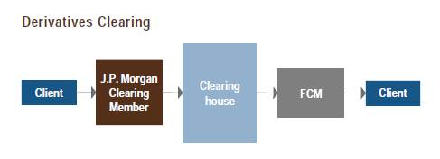

In this post trade model, all the counterparty risk across cleared derivatives is passed off and centralized at the Clearing house. The Clearing member (J.P. Morgan in this case) assumes the counterparty risk of Tiger Corp; executing broker (EB) and Tiger Corp have mutualized their counterparty risk at the clearing house and retain their respective market risk.